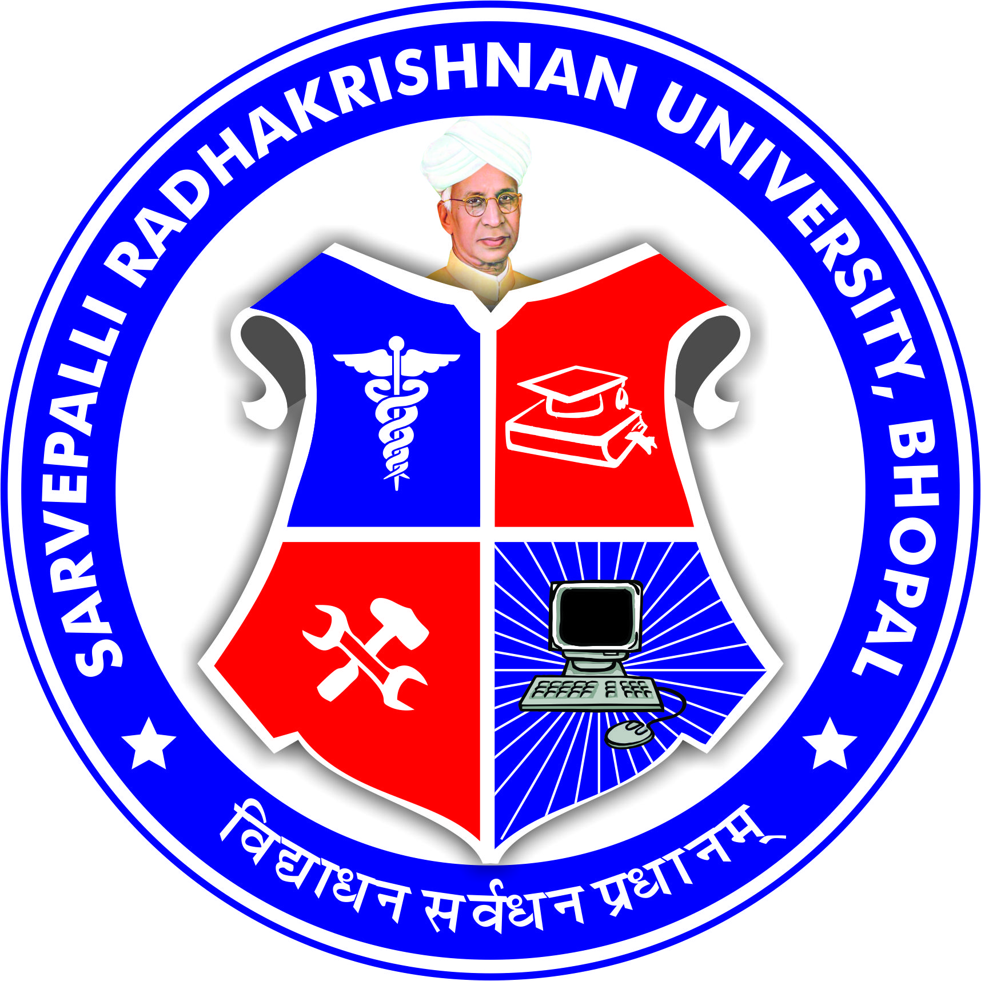
SARVEPALLI RADHAKRISHNAN UNIVERSITY
NH 12,RKDF IST CAMPUS, HOSHANGABAD ROAD, MISROD, BHOPAL (M.P.)
¼Statutory University established by Govt. of M.P. under section 2(F½ of UGC act)
www.srku.edu.in, info@srku.edu.in,Phone: 0755-4700981 Fax: 07554700981

Governing Body
Order
As per the provision of statute No. 9 the Governing Body of Sarvepalli Radhakrishnan University is reconstituted as under: -

1 | Smt. Janak Kapoor  3/4 Arera Colony, Bhopal  Phone: 0755-4700983 | Chancellor | Chairman
2 | Dr. Priyanka Jaiswal  M-04, Aashima Anupama City, Katara  Hills, Bagmugaliya, Bhopal-462043  Phone: 8462834789 | Vice Chancellor | Member
3 | Shri. Sunil Patil  19 Sector-3 Global Park City Katara Hills Bhopal  Phone : 9977700545 | Sponsoring Body  Nominee | Member
4 | Dr. Chinmay Bhatt  RKDF IST Campus, NH-12, Bhopal  Phone : 9584232402 | Sponsoring Body  Nominee | Member
5 | Dr. Dipika Pathak  CIIT Indore  Phone : 9009771717 | Sponsoring Body  Nominee | Member
6 | Shri Manoj Kumar Saryam, IAS Addl. DME, Bhopal  Phone: 9981185612 | State Govt.  Nominee | Member
7 |  | Visitor/Governor Nominee Awaited | Member
8 |  | Visitor/Governor Nominee Awaited | Member
9 |  | Visitor/Governor Nominee Awaited | Member
10 | Dr.S.S. Pawar  A-11 Fortune Pearl Danish Nagar Hoshangabad Road Bhopal  Phone : 7770907071 | Registrar | Member Secretary

Registrar

SARVEPALLI RADHAKRISHNAN UNIVERSITY
NH 12,RKDF IST CAMPUS, HOSHANGABAD ROAD, MISROD, BHOPAL (M.P.)
¼Statutory University established by Govt. of M.P. under section 2(F½ of UGC act)
www.srku.edu.in, info@srku.edu.in,Phone: 0755-4700981 Fax: 07554700981

No. Date.

Board of management
Order
As per the provision of statute No. 10 the Board of Management of Sarvepalli Radhakrishnan University is reconstituted as under:-

1 | Dr. Priyanka Jaiswal  M-04, Aashima Anupama City, Katara  Hills, Bagmugaliya, Bhopal-462043  Phone: 8462834789 | Vice Chancellor | Chairman
2 | Shri. Ratnesh Jain  104 Geet Mohini Ayodhya Bye Pass Bhopal  Phone : 9826048401 | Sponsoring Body  Nominee | Member
3 | Dr. Namish Mehta  Phone : | Sponsoring Body  Nominee | Member
4 | Dr. Sushil Singh  Phone : | Senior Prof. | Member
5 | Dr. Bhavika Bhavsar  Phone : | Senior Prof. | Member
6 | Mr. Santosh Negi  Block B/5 Plat No. 406 Shiv Aavgan Society Salaiya Bhopal  Phone : 7566863834 | Senior Teacher | Member
7 | Dr. Bharti Chaursiya  Phone : | Senior Teacher | Member
8 | Professor | State Govt.  Nominee | Member  awaited
9 | Professor | State Govt.  Nominee | Member  awaited
10 | Dr. S.S. Pawar  A-11 Fortune Pearl Danish Nagar Hoshangabad Road Bhopal  Phone : 7770907071 | Registrar | Member Secretary

Registrar

